Explaining changes in foot morphology during gait through 4D scanning and shape modeling

Abstract will go here.

# Introduction

Foot shape is known to vary widely throughout the population. For example, female feet are shaped differently from male feet even when standardizing for foot length (Wunderlich and Cavanagh 2001; Krauss et al. 2008), suggesting that female feet are not simply scaled down male feet (Krauss et al. 2010). Foot measurements are also affected by age (Tomassoni, Traini, and Amenta 2014) and weight (Price and Nester 2016). This variability is not often captured in sizing. Current footwear fitting standards, though, only use foot length, foot width, and arch length to fit to standardized shoe sizes (“Standard Practice for Fitting Athletic Footwear” 2017). Further, footwear is commonly designed around lasts, shoe molds are sized and shaped by each manufacturer with no common standard, leading to variability in shapes and sizes (Jurca and Dzeroski 2013; Wannop et al. 2019). Such variability can make it hard for consumers to find a proper fit, resulting in users having to wear ill-fitting footwear with suboptimal comfort and performance (Dobson et al. 2018). Comfort is often the number one (Martínez-Martínez et al. 2017) factor for consumers to select footwear, thereby requiring footwear to be properly fit to a wide population range in order to be successful.

However, because the current methodology of designing footwear relies on using static lasts, this assumes the foot consists of rigid segments. This fails to account for dynamic changes in foot morphology, especially when the foot is being loaded during gait Assumptions of rigid foot segments during foot loading have shown inaccuracies in estimation of ankle joint mechanics (Zelik and Honert 2018; Kessler et al. 2020), suggesting intra-foot motion as the foot is loaded. Evidence suggests that foot loading affects linear foot measurements, such as when transitioning from sitting to standing (Xiong et al. 2009; Oladipo, Bob-Manuel, and Ezenatein 2008). Studies have also explored changes in linear, circumfrential, and angular measurments during stance phase loading. Girth along the foot’s dorsal surface has been shown to decrease during stance phase (Barisch-Fritz et al. 2014a; Grau and Barisch-Fritz 2018). Heel width, heel inclination forefoot width, and longitudinal arch length were all shown to increase during stance phase (Kouchi, Kimura, and Mochimaru 2009; Barisch-Fritz et al. 2014a; Grau and Barisch-Fritz 2018). The dynamically changing measurements suggest morphological changes occuring, all of which may not be captured in the linear and circumferential measurements. Thus, i

Dynamic changes in foot measurements were shown to not be significantly different between adults of different ages, sex, or body-mass-index (BMI) (Grau and Barisch-Fritz 2018). However, different patterns of ball-joint deformation were observed between male and female subjects, as well as children and adolescent subjects (Barisch-Fritz et al. 2014b).

To address the need for a more nuanced understanding of morphological difference across populations, statistical shape models (SSMs) have been widely used. These have ben developed for whole-body digital human modeling applications to study population and individual variance in body shape (Allen, Curless, and Popović 2003; Anguelov et al. 2005; Reed et al. 2014; Park and Reed 2015; Park, Ebert, and Reed 2017). SSMs aim to describe the population’s body shape as deformations from a mean body shape. SSMs can also be developed into parametric models which use correlations between subject anthropometric data and SSM deformations to help predict body shape for new individuals in the population (Park and Reed 2015; Park, Ebert, and Reed 2017).

SSMs have recently been applied to characterize static foot shape across a population (Conrad et al. 2019) and recognize foot-shape deviations (Stanković et al. 2020). However, SSMs have not been previously used to create statistical foot shape models incorporating changes over the gait cycle. Because of the aforementioned critical impact gait has on foot morphology, there have been limited efforts to capture foot 3D foot shape over time. However, previously developed 4D scanning systems suitable for capturing foot morphology during gait did not capture the whole dorsal surface of the foot (Schmeltzpfenning et al. 2009; Barisch-Fritz et al. 2014a; Grau and Barisch-Fritz 2018) or had a frame rate of only 14 fps (Kouchi, Kimura, and Mochimaru 2009) which is insufficient to capture morphology transitions on the order of tenths of seconds. All the previously developed systems were also based on a catwalk, requiring subjects to correctly hit the scanning area for a successful data capture, which may not be representative of natural cadence.

The development of the DynaMo software (Boppana and Anderson 2019) for the Intel RealSense D415 Depth Cameras (Intel, Santa Clara CA) allowed a 4D scanning system to be set around a treadmill, where subjects can maintain a natural cadence. This system captures the majority of the foot’s dorsal surface, but does not allow for the capture of the foot’s plantar surface. 4D scans are captured at 90 fps, enabling a detailed evaluation of foot morphology changes during loading and unloading. This study outlines the development of a parametric SSM derived from scans captured with this system. This work characterizes dynamic foot morphology by predicting shape during specific points of the gait cycle, captured across the subject population. We hypothesize that there will be significant changes in foot morphology across the dorsal surface of the foot throughout the gait cycle. We also hypothesize that these changes will be predictable from the subject demographics of our population.

# Methods

## Subjects

A total of 30 healthy subjects (15 men and 15 women, ages 23.1 $±$ 3.7) participated in this study. Subjects were recruited in a stratified sample into one of six groups (5 subjects per group) to maximize variance in population foot length. Height was used as the grouping factor since height is well correlated to foot length (Giles and Vallandigham 1991). The general population may not know offhand their exact foot length and shoe size varies by manufacturer and does not correspond directly to foot length (Jurca and Dzeroski 2013; Wannop et al. 2019). Groups consisted of 5th-35th, 35th-65th, and 65th-95th height percentiles for each sex. Height percentile values were taken from the ANSUR II survey (Gordon et al. (2014)) and converted to imperial units as it was expected most subjects would report their height in imperial units. Population recruitment groups are summarized in tbl. 1.

Prior to recruitment, subjects completed a prescreening survey to ensure they were adequately healthy by the American College of Sports Medicine guidelines(Riebe et al. 2015), and between the ages of 18-65. Subjects provided their sex and height, and were only enrolled in the study if their population group was not fully enrolled.

Table 1: Enrollment groups based on reported height. 5 subjects were enrolled in each group

|  |  |  |  |
| --- | --- | --- | --- |
| Sex | 5th-35th percentile Height | 35th-65th percentile Height | 65th-95th percentile Height |
| Female | 4’11“-5’3” | 5’3“-5’5” | 5’5“-5’8” |
| Male | 5’4“-5’8” | 5’8“-5’11” | 5’11“-6’2” |

## Experimental Procedures

The experimental protocol was approved by the University of Colorado Institutional Review Board. Procedures were explained to each subject and written consent was obtained prior to participation. Subjects’ height and weight were recorded with a tape measure and scale, respectively. Subjects’ foot length, foot width, and arch length were measured with a Brannock device (The Brannock Device Company, Liverpool, NY) (“Standard Practice for Fitting Athletic Footwear” 2017). Both foot length and arch length were measured in centimeters. Foot width was measured as an ordinal size (e.g. A, B, C, D, E), and then converted to a linear measurement in centimeters using the following formula (The Brannock Device Company, Liverpool, NY):

$$w_{cm}=(3+(w_{offset}*3/16)+(l*(1/2.54)-8)*3/8)*2.54$$

where $w_{cm}$ is the foot width in centimeters, $w_{offset}$ is the foot width size offset from standard size D, and $l$ is the foot length in centimeters.

Six Intel RealSense D415 Depth Cameras (Intel, Santa Clara, CA) were placed and calibrated around a custom-built level treadmill in the University of Colorado Boulder Locomotion Laboratory, as shown in fig. 1. The DynaMo software package was used to capture depth images of the right foot at 90 frames-per-second while subjects walked on the treadmill (Boppana and Anderson 2019). For each captured frame, the depth images were converted into a single point cloud using the known camera intrinsic and extrinsic properties (Boppana and Anderson 2019).

Subjects walked on the treadmill set at an average walking pace of 1.4 m/s (Browning et al. 2006). Reflective markers were placed on the subject’s right foot and a black sock over their left foot to aid in object identification described later. Subjects first walked for one minute to warm-up and fall into a natural cadence. The operator then collected 10 seconds of data to capture approximately 10 steps. The data were reviewed to ensure the subject stayed in frame from heel-strike to toe-off during capture. If needed, the subject’s placement was shifted and data was collected again, up to two times.

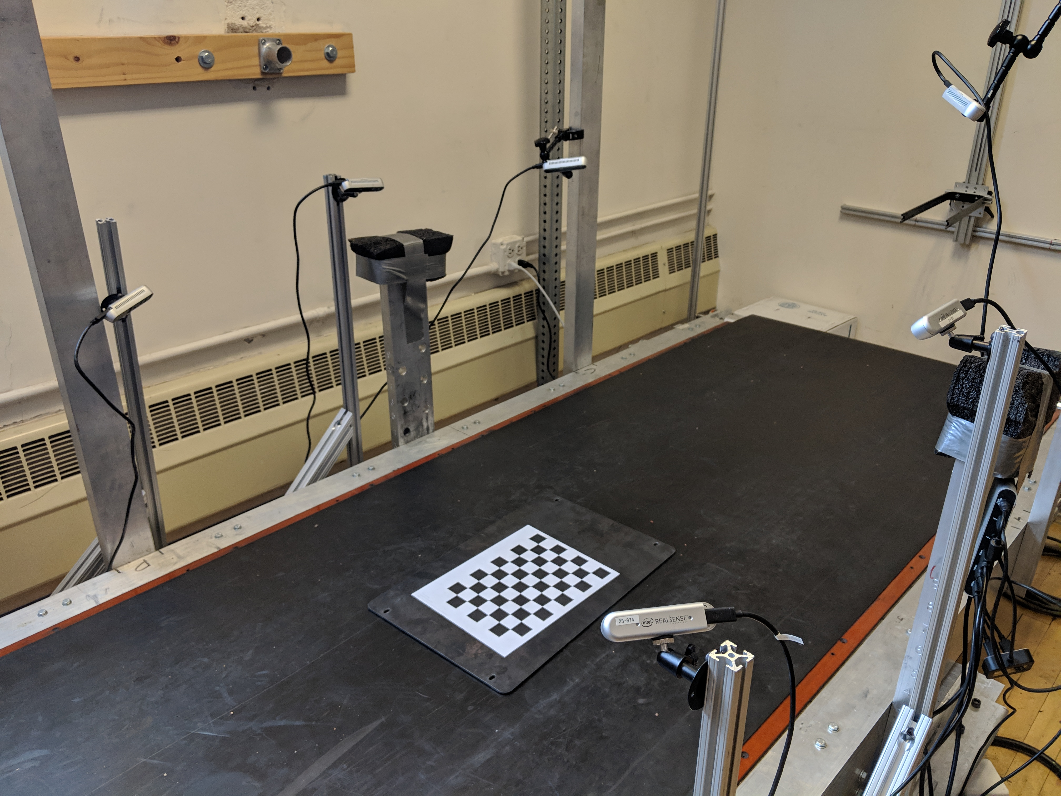

Figure 1: Capture setup of 6 Intel RealSense D415 Depth Cameras placed around a treadmill. The checkerboard shown was used to calibrate the cameras using the DynaMo package

## Data Processing

Since every depth image and point cloud reconstruction for each frame was captured independently by the cameras, the amount and location of points which represent the foot in the data were not consistent. In addition, the captured data may have holes in the surface representing the foot. Captured depth images were processed into meshes and registered to a common template to fill holes and represent each scan with an equal number of points to aid statistical analysis. Registered scans were then used to create a SSM representing changes in dynamic foot morphology. This was then used to reconstruct predicted foot shape along the gait cycle using subject’s demographic features. The following sections detail the mesh processing, registration, and SSM construction process, with fig. 2 summarizing the data processing steps.

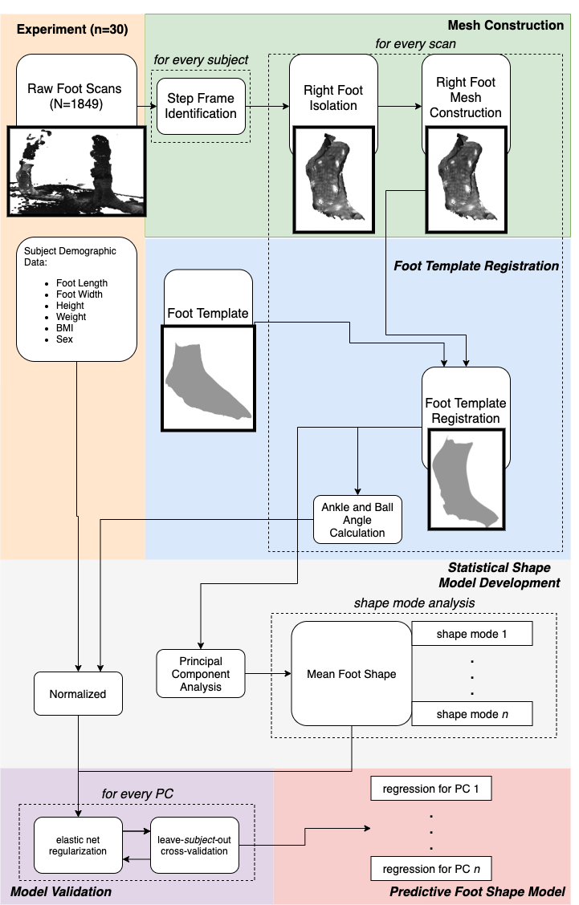

Figure 2: Flowchart of processing steps for statistical shape model creation

### Mesh Construction

All data was processed into a series of low-resolution point clouds with the DynaMo package to identify heel-strike to toe-off times. For each subject, a candidate heel-strike to toe-off event was manually identified across all captures by taking into account point cloud quality. A single heel-strike to toe-off event was identified. For each event, point clouds were reconstructed by converting the depth images into full-resolution point clouds.

The C++ implementation of the PointCloud Library (Rusu and Cousins 2011) was used to identify and isolate the right foot from the point set. First, the point clouds were downsampled with a voxel size of 3 mm to reduce required computing power. A RANSAC algorithm (Fischler and Bolles 1981) was used to identify the flat treadmill floor with a plane model, and remove it from the point cloud. Euclidean cluster extraction was then used to detect the point clusters that make up each foot. The total color value of each point cluster was used to identify the right foot from the left foot, as the left foot had a lower total color value due to the black sock. The left foot was then removed from the point cloud, leaving only the right foot for processing.

Surface reconstruction was done through Meshlab (Cignoni et al. 2008). A surface mesh adds a topological layer interpreted from the pointcloud. Point normals were calculated for the point cloud using the 10 nearest neighbors. An APSS Marching Cubes algorithm (Guennebaud and Gross 2007; Guennebaud, Germann, and Gross 2008) is then used with the point normals to estimate the surface from the point cloud and construct the foot scan mesh.

### Foot Template Registration

Point cloud registration to a template assists statistical analysis by reconstructing the subject data to a common template with a standardized number of points. A foot template was provided by collaborators Reed and Corner, and was derived from an average set of scans taken with a high-quality static 3D foot scanner (Reed, Ebert, and Corner 2013). The toes were smoothed into a single structure and parts of the upper shank removed to be better fit to the captured data, with a finalized structure of 29903 points. The overall registration process follows a two-step process: a rough alignment followed by a radial-basis function (RBF) fine alignment.

The registration process was first completed for each subject’s data with a foot scan mesh manually identified near mid-stance. A point-to-plane iterative-closest-point (ICP) algorithm (Chen and Medioni 1992) was used to roughly align the template foot to the scan mesh with the Open3D library (Zhou, Park, and Koltun 2018).

Corresponding points between both the scan mesh and the ICP-aligned template were found using a radial-search KD-Tree implemented in the Open3D library (Zhou, Park, and Koltun 2018). Any points on the scan mesh which were not within 1 cm of a corresponding point on the aligned template were deleted; these points represented parts of the treadmill floor which were missed in the RANSAC identification and parts of the upper shank. Similarly, any points on the template not within 1cm of a corresponding point on the scan mesh were temporarily set aside from the template; these points correspond to those near holes in the scan mesh which would be refilled in later processing

Thin-plate spline RBFs have been used to surface fit templates to scanned body shapes (Park and Reed 2015; Kim et al. 2016), and so were used in two stages in this research. A first-pass RBF registration was done between the template and the scan using the GIAS2 package (Zhang, Hislop-Jambrich, and Besier 2016). A thin-plate spline RBF was used for interpolation. To prevent overfitting of the RBF to the noise on the edges of the captured pointcloud, a maximum of five iterations were done on the first-pass RBF registration process. The first-pass registered RBF template was then appended with the points previously removed from the template. This intermediate template represents the template fitted to the known scan data, with any unknown sections (e.g., holes in the scan data) taking the value of the template. However, the disparity between the known and unknown sections created major steps in the morphed template not representative of the scan data.

A second-pass RBF registration was done from the ICP-aligned template to the intermediate template with the same parameters as the first-pass registration. This smooths out the unknown sections representing holes in the scan data with the surrounding known sections. The second-pass registered template is saved as the final registered template.

Following the registration of the mid-stance scan, the process is repeated both forwards towards toe-off and backwards toward heel-strike on a scan-by-scan basis. In this iterative fashion, the previous scan’s registered template is used as the template for the following scan. During the iterative registration process, the RBF alignment is only conducted for one iteration for both the first-pass and second-pass to prevent over-fitting. On average, this was done for XX scans per person.

The registered templates were then compared against the initial scans to ensure they accurately represented the captured scan data. Comparisons were done by finding corresponding points between the scan data and the registered template, and calculating the root-mean-squared error (RMSE) between the corresponding points.

The original template identified certain vertices as anatomical landmarks. These landmark vertices were conserved through the registration process on our subjects; they can therefore be used to identify the anatomical landmarks on the registered scans. The lateral malleolus, medial malleolus, lateral metatarsal, medial metatarsal, and 2nd phalange landmarks were taken from the template, while new landmark vertices for the lateral shank and medial shank were manually picked on the template.

Post-registration scans were aligned to a common coordinate frame based around the metatarsophalangeal (MTP) joint. The origin was defined as the point along the vector from the lateral metatarsal landmark to the medial metatarsal landmark which is orthogonal to the second phalange. From the origin, the x-axis was defined as pointing towards the medial metatarsal, the y-axis was defined as pointing towards the lateral metatarsal, and the z-axis was the cross-product of both x- and y-axes. This coordinate system is shown in fig. 3.

The MTP and ankle joint angles were calculated post-registration for each scan from the anatomical segments of the shank, midfoot, and phalanges. The shank center was defined as the center between the lateral shank and medial shank landmarks. The MTP center was defined as the center between the lateral metatarsal and medial metatarsal landmarks. The shank’s normal vector was defined as the cross-product of the vector from the shank center to the lateral malleolus, and the vector from the shank center to the medial malleolus. The midfoot’s normal vector was defined as the cross-product of the vector from the MTP center to the lateral malleolus, and the MTP center to the medial malleolus. The phalanges’ normal vector was defined as the cross product from the 2nd toe to the lateral metatarsal, and from the 2nd toe to the medial metatarsal.

The MTP joint angle was calculated as the acute angle between the phalanges’ normal vector and the midfoot’s normal vector. The ankle joint angle was calculated as the acute angle between the midfoot’s normal vector and the shank’s normal vector.

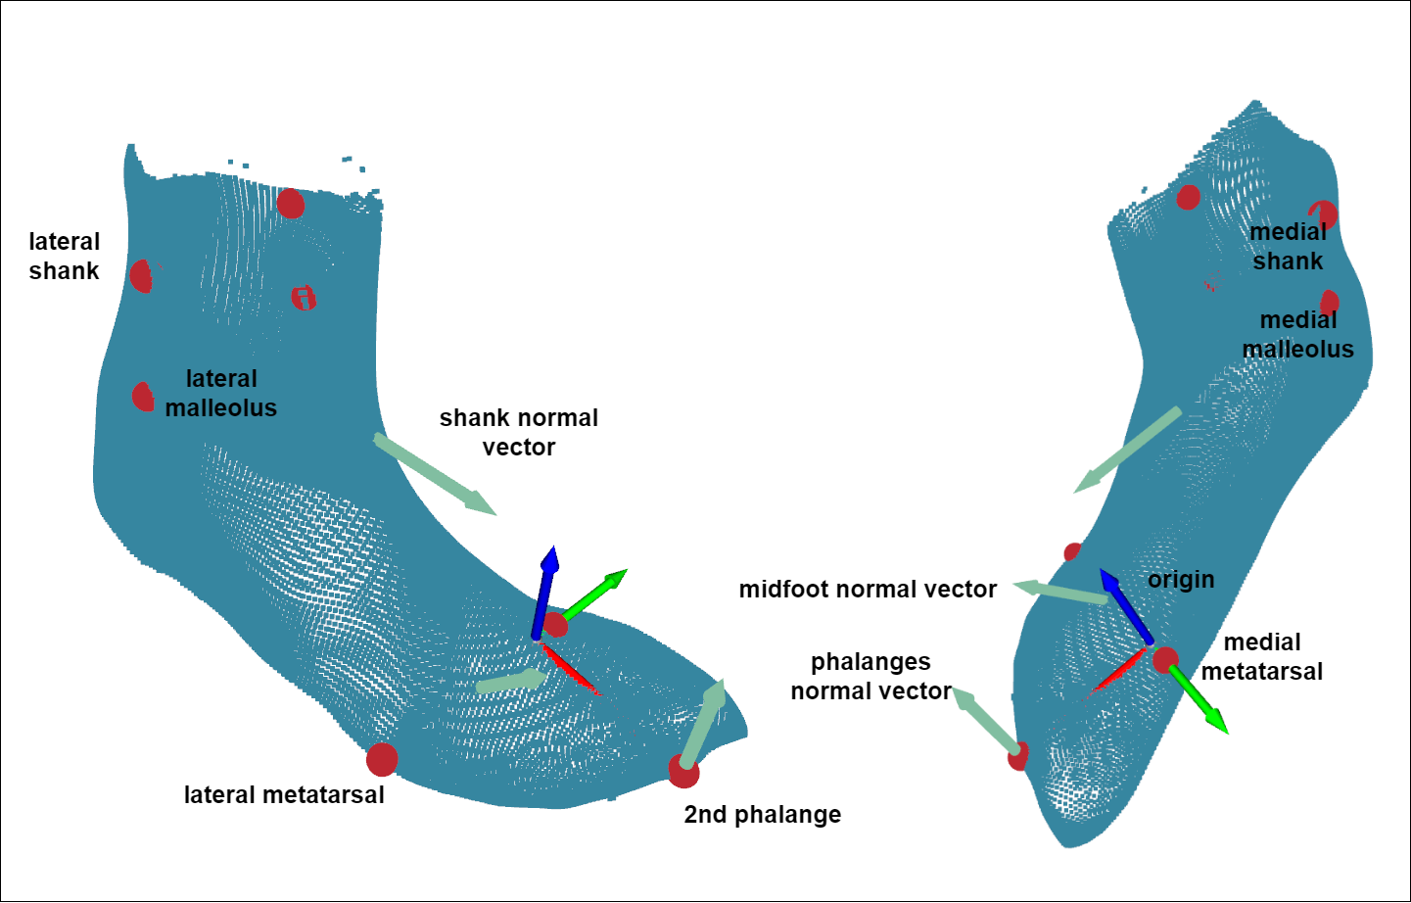

Figure 3: Anatomical landmarks, coordinate system, and vectors defining anatomical segments of a registered scan

### Statistical Shape Model Development

Principal component (PC) analysis is a dimensionality-reduction method commonly used to build statistical body shape models in digital human modelling, with applications for whole-body (Reed and Parkinson 2008; Park and Reed 2015) as well as foot shape models (Conrad et al. 2019; Stanković et al. 2020). The first PC represents an axis containing the largest variance in the dataset, and each subsequent PC describes the largest variance orthogonal to the previous component’s axis. Therefore, PCs allow for a new, smaller set of orthogonal variables to be defined which represent the variance in the dataset.

Let $N$ equal the number of total scans in the dataset, and $n$ equal the number of vertices in each registered scan. Each registered scan is represented as an $n×3$ array, with columns describing the x,y, and z locations of each vertex, respectively. Therefore, the entire dataset of registered scans is represented as a 3D $N×n×3$ array. This dataset was reshaped into a 2D $N×(n×3)$ array by flattening each scan.

The scikit-learn module (Pedregosa et al. 2011) was used to incrementally calculate the $(N-1)$ PCs of the reshaped dataset. The resultant PC model can be used to inverse transform an vector of length $(N-1)$ PC scores into a $(n×3)$ length vector, which can then be reshaped into a $n×3$ array representing a foot shape.

Each scan in the dataset is represented in the PC model with $n-1$ PC scores. All PC scores are centered around 0, which represents the mean foot scan of the dataset containing all subjects ($\overset{‾}{x}$). Each PC represents a shape mode in the SSM, where each score represents a deviation from the mean foot along the shape mode axis.

Not all shape modes were retained in the SSM, since the first few PCs explained the majority of the variance. The number of PCs to explain 95%, 97.5% and 99.2% of the variance was calculated from the dataset. PC scores not retained were set to 0 when inverse-transforming the PC scores to foot shape.

### Model Construction and Validation

Subject demographic data and calculated joint angles were incorporated into the SSM by developing multivariate linear regression models based on these features This was used to predict each PC score, which can then be inverse-transformed into a foot shape. Subject demographic data and joint angles were normalized to aid in regression development. First order interaction terms were calculated for all demographic data and joint angles. An elastic net regularization algorithm [REF] was run for each multivariate regression to calculate feature coefficients for each PC score’s regression. Normalized coefficients below 0.05 were not included in regression models due to their minimal influence on the predicted PC score.

The number of shape modes retained in the predictive model was tested by building models which predict the number of PCs that explain 95%, 97.5%, and 99.2% of the variance. Models were also built with all subject demographic features, and after removing highly cross-correlated subject features of height (correlated with foot length), weight (correlated to BMI and foot length), and gait cycle (correlated with ankle angle and ball angle).

All models were validated for performance using leave-*p*-out cross-validation, where scans from each subject were set as the validation set, and models were trained on the remaining dataset.

Model performance was quantified with the root mean squared error of the predicted foot shape to the corresponding scan during validation. The predicted foot shape is rigidly aligned to the scan through a least-squares alignment; rigid-alignment preserves morphology by only rotating and translating the foot shape. For every point in the scan, the nearest vertex in the predicted foot shape found by searching a KD-tree of the foot shape. The distance between the two corresponding points is taken as the prediction error. The root mean squared error of these distances is calculated for every scan tested.

Following model validation, the selected model’s regressions for each PC score were compiled into a custom Python function to predict foot shape based on subject demographic data through the gait cycle.

# Results

# Conclusion and Outlook

Allen, Brett, Brian Curless, and Zoran Popović. 2003. “The space of human body shapes: Reconstruction and parameterization from range scans.” *ACM Transactions on Graphics* 22 (3): 587–94. <https://doi.org/10.1145/882262.882311>.

Anguelov, Dragomir, Praveen Srinivasan, Daphne Koller, Sebastian Thrun, Jim Rodgers, and James Davis. 2005. “SCAPE: Shape Completion and Animation of People.” *ACM Transactions on Graphics* 24 (3): 408–16. <https://doi.org/10.1145/1073204.1073207>.

Barisch-Fritz, Bettina, Timo Schmeltzpfenning, Clemens Plank, Tobias Hein, and Stefan Grau. 2014a. “The effects of gender, age, and body mass on dynamic foot shape and foot deformation in children and adolescents.” *Footwear Science* 6 (1): 27–39. <https://doi.org/10.1080/19424280.2013.834982>.

———. 2014b. “The effects of gender, age, and body mass on dynamic foot shape and foot deformation in children and adolescents.” *Footwear Science* 6 (1): 27–39. <https://doi.org/10.1080/19424280.2013.834982>.

Boppana, Abhishektha, and Allison P Anderson. 2019. “DynaMo: Dynamic Body Shape and Motion Capture with Intel RealSense Cameras.” *The Journal of Open Source Software* 4 (41). <https://doi.org/10.21105/joss.01466>.

Browning, Raymond C., Emily A. Baker, Jessica A. Herron, and Rodger Kram. 2006. “Effects of obesity and sex on the energetic cost and preferred speed of walking.” *Journal of Applied Physiology* 100 (2): 390–98. <https://doi.org/10.1152/japplphysiol.00767.2005>.

Chen, Yan, and Gerard Medioni. 1992. “Object modelling by registration of multiple range images.” *Image and Vision Computing* 10 (3): 2724–9. [https://graphics.stanford.edu/{~}smr/ICP/comparison/chen-medioni-align-rob91.pdf](https://graphics.stanford.edu/%7B~%7Dsmr/ICP/comparison/chen-medioni-align-rob91.pdf).

Cignoni, P., M. Callieri, M. Corsini, M. Dellepiane, F. Ganovelli, and G. Ranzuglia. 2008. “MeshLab: An open-source mesh processing tool.” *6th Eurographics Italian Chapter Conference 2008 - Proceedings*, 129–36.

Conrad, Bryan P., Michael Amos, Irene Sintini, Brian Robert Polasek, and Peter Laz. 2019. “Statistical shape modelling describes anatomic variation in the foot.” *Footwear Science* 11 (sup1): S203–S205. <https://doi.org/10.1080/19424280.2019.1606334>.

Dobson, Jessica A., Diane L. Riddiford-Harland, Alison F. Bell, and Julie R. Steele. 2018. “The three-dimensional shapes of underground coal miners’ feet do not match the internal dimensions of their work boots.” *Ergonomics* 61 (4): 588–602. <https://doi.org/10.1080/00140139.2017.1397201>.

Fischler, Martin A., and Robert C. Bolles. 1981. “Random sample consensus: A Paradigm for Model Fitting with Applications to Image Analysis and Automated Cartography.” *Communications of the ACM* 24 (6): 381–95. <https://doi.org/10.1145/358669.358692>.

Giles, Eugene, and Paul H. Vallandigham. 1991. “Height Estimation from Foot and Shoeprint Length.” *Journal of Forensic Sciences* 36 (4): 13129J. <https://doi.org/10.1520/jfs13129j>.

Gordon, Claire C., Cynthia L. Blackwell, Bruce Bradtmiller, Joseph L. Parham, Patricia Barrientos, Stephen P. Paquette, Brian D. Corner, et al. 2014. “2012 Anthropometric Survey of U.S. Army Personnel: Methods and Summary Statistics.” Natick, MA: ARMY NATICK SOLDIER RESEARCH DEVELOPMENT AND ENGINEERING CENTER MA. <https://apps.dtic.mil/docs/citations/ADA611869>.

Grau, Stefan, and Bettina Barisch-Fritz. 2018. “Improvement of safety shoe fit - evaluation of dynamic foot structure.” *Footwear Science* 10 (3): 179–87. <https://doi.org/10.1080/19424280.2018.1529062>.

Guennebaud, Gaël, Marcel Germann, and Markus Gross. 2008. “Dynamic sampling and rendering of algebraic point set surfaces.” *Computer Graphics Forum* 27 (2): 653–62. <https://doi.org/10.1111/j.1467-8659.2008.01163.x>.

Guennebaud, Gaël, and Markus Gross. 2007. “Algebraic point set surfaces.” *Proceedings of the ACM SIGGRAPH Conference on Computer Graphics*. <https://doi.org/10.1145/1275808.1276406>.

Jurca, Ales, and Saso Dzeroski. 2013. “Length dispersion of shoes labelled with the same size in the UK shoe-size system.” *Footwear Science* 5 (SUPPL. 1): 2–5. <https://doi.org/10.1080/19424280.2013.799543>.

Kessler, Sarah E., Glen A. Lichtwark, Lauren K. M. Welte, Michael J. Rainbow, and Luke A. Kelly. 2020. “Regulation of foot and ankle quasi-stiffness during human hopping across a range of frequencies.” *Journal of Biomechanics*, 109853. <https://doi.org/10.1016/j.jbiomech.2020.109853>.

Kim, K. Han, Karen S. Young, Yaritza Bernal, Abhishektha Boppana, Linh Q. Vu, Elizabeth A. Benson, Sarah Jarvis, and Sudhakar L. Rajulu. 2016. “A Parametric Model of Shoulder Articulation for Virtual Assessment of Space Suit Fit.” In *Proceedings of the 7th International Conference on 3D Body Scanning Technologies*, 201–7. Lugano, Switzerland. <https://doi.org/10.15221/16.201>.

Kouchi, Makiko, Makoto Kimura, and Masaaki Mochimaru. 2009. “Deformation of foot cross-section shapes during walking.” *Gait and Posture* 30 (4): 482–86. <https://doi.org/10.1016/j.gaitpost.2009.07.113>.

Krauss, I., S. Grau, M. Mauch, C. Maiwald, and T. Horstmann. 2008. “Sex-related differences in foot shape.” *Ergonomics* 51 (11): 1693–1709. <https://doi.org/10.1080/00140130802376026>.

Krauss, Inga, Gordon Valiant, Thomas Horstmann, and Stefan Grau. 2010. “Comparison of female foot morphology and last design in athletic footwear-are men’s lasts appropriate for women?” *Research in Sports Medicine* 18 (2): 140–56. <https://doi.org/10.1080/15438621003627216>.

Luo, Geng, Pro Stergiou, Jay Worobets, Benno Nigg, and Darren Stefanyshyn. 2009. “Improved footwear comfort reduces oxygen consumption during running.” *Footwear Science* 1 (1): 25–29. <https://doi.org/10.1080/19424280902993001>.

Martínez-Martínez, José M., José D. Martín-Guerrero, Emilio Soria-Olivas, José A. Bernabeu, Pablo Escandell-Montero, Rafael Hernández Stark, Antonio J. Serrano-López, and Enrique Montiel. 2017. “Use of SOMs for footwear comfort evaluation.” *Neural Computing and Applications* 28 (7): 1763–73. <https://doi.org/10.1007/s00521-015-2139-x>.

Meyer, Christian, Maurice Mohr, Mathieu Falbriard, Sandro R. Nigg, and Benno M. Nigg. 2018. “Influence of footwear comfort on the variability of running kinematics†.” *Footwear Science* 10 (1): 29–38. <https://doi.org/10.1080/19424280.2017.1388296>.

Mündermann, A., D. J. Stefanyshyn, and B. M. Nigg. 2001. “Relationship between footwear comfort of shoe inserts and anthropometric and sensory factors.” *Medicine and Science in Sports and Exercise* 33 (11): 1939–45. <https://doi.org/10.1097/00005768-200111000-00021>.

Oladipo, G, I Bob-Manuel, and G Ezenatein. 2008. “Different Weight Bearing Conditions Amongst Nigerians.” *The Internet Journal of Biological Anthropology* 3 (1): 1–7.

Park, Byoung Keon D., Sheila Ebert, and Matthew P. Reed. 2017. “A parametric model of child body shape in seated postures.” *Traffic Injury Prevention* 18 (5): 533–36. <https://doi.org/10.1080/15389588.2016.1269173>.

Park, Byoung Keon, and Matthew P. Reed. 2015. “Parametric body shape model of standing children aged 3–11 years.” *Ergonomics* 58 (10): 1714–25. <https://doi.org/10.1080/00140139.2015.1033480>.

Pedregosa, Fabian, Ron Weiss, Matthieu Brucher, Gaël Varoquaux, Alexandre Gramfort, Vincent Michel, Bertrand Thirion, et al. 2011. “Scikit-learn: Machine Learning in Python.” *Journal of Machine Learning Research* 12 (85): 2825–30. <https://doi.org/10.1145/2786984.2786995>.

Price, Carina, and Christopher Nester. 2016. “Foot dimensions and morphology in healthy weight, overweight and obese males.” *Clinical Biomechanics* 37: 125–30. <https://doi.org/10.1016/j.clinbiomech.2016.07.003>.

Reed, Matthew P, Sheila M Ebert, and Brian D Corner. 2013. “Statistical Analysis to Develop a Three-Dimensional Surface Model of a Midsize-Male Foot.” October.

Reed, Matthew P., and Matthew B. Parkinson. 2008. “Modeling variability in torso shape for chair and seat design.” *Proceedings of the ASME Design Engineering Technical Conference* 1 (PARTS A AND B): 561–69. <https://doi.org/10.1115/DETC2008-49483>.

Reed, M. P., Ulrich Raschke, Rishi Tirumali, and M. B. Parkinson. 2014. “Developing and Implementing Parametric Human Body Shape Models in Ergonomics Software.” *3rd Digital Human Modeling Symposium*, no. 1: 1–8.

Riebe, Deborah, Barry A. Franklin, Paul D. Thompson, Carol Ewing Garber, Geoffrey P. Whitfield, Meir Magal, and Linda S. Pescatello. 2015. “Updating ACSM’s recommendations for exercise preparticipation health screening.” *Medicine and Science in Sports and Exercise* 47 (11): 2473–9. <https://doi.org/10.1249/MSS.0000000000000664>.

Rusu, Radu Bogdan, and Steve Cousins. 2011. “3D is here: Point Cloud Library (PCL).” In *Proceedings - Ieee International Conference on Robotics and Automation*. Shanghai, China. <https://doi.org/10.1109/ICRA.2011.5980567>.

Schmeltzpfenning, Timo, Clemens Plank, Inga Krauss, Petra Aswendt, and Stefan Grau. 2009. “Dynamic foot scanning: A new approach for measurement of the human foot shape while walking.” *Footwear Science* 1 (sup1): 28–30. <https://doi.org/10.1080/19424280902977111>.

“Standard Practice for Fitting Athletic Footwear.” 2017. ASTM. <https://doi.org/10.1520/F0539-01R11.2>.

Stanković, Kristina, Toon Huysmans, Femke Danckaers, Jan Sijbers, and Brian G. Booth. 2020. “Subject-specific identification of three dimensional foot shape deviations using statistical shape analysis.” *Expert Systems with Applications* 151 (August): 113372. <https://doi.org/10.1016/j.eswa.2020.113372>.

Tomassoni, Daniele, Enea Traini, and Francesco Amenta. 2014. “Gender and age related differences in foot morphology.” *Maturitas* 79 (4): 421–27. <https://doi.org/10.1016/j.maturitas.2014.07.019>.

Wannop, John W., Darren J. Stefanyshyn, Robert B. Anderson, Michael J. Coughlin, and Richard Kent. 2019. “Development of a Footwear Sizing System in the National Football League.” *Sports Health* 11 (1): 40–46. <https://doi.org/10.1177/1941738118789402>.

Wunderlich, R. E., and P. R. Cavanagh. 2001. “Gender differences in adult foot shape: Implications for shoe design.” *Medicine and Science in Sports and Exercise* 33 (4): 605–11. <https://doi.org/10.1097/00005768-200104000-00015>.

Xiong, Shuping, Ravindra S. Goonetilleke, Jianhui Zhao, Wenyan Li, and Channa P. Witana. 2009. “Foot deformations under different load-bearing conditions and their relationships to stature and body weight.” *Anthropological Science* 117 (2): 77–88. <https://doi.org/10.1537/ase.070915>.

Zelik, Karl E., and Eric C. Honert. 2018. “Ankle and foot power in gait analysis: Implications for science, technology and clinical assessment.” *Journal of Biomechanics* 75: 1–12. <https://doi.org/10.1016/j.jbiomech.2018.04.017>.

Zhang, Ju, Jacqui Hislop-Jambrich, and Thor F. Besier. 2016. “Predictive statistical models of baseline variations in 3-D femoral cortex morphology.” *Medical Engineering and Physics* 38 (5): 450–57. <https://doi.org/10.1016/j.medengphy.2016.02.003>.

Zhou, Qian-Yi, Jaesik Park, and Vladlen Koltun. 2018. “Open3D: A Modern Library for 3D Data Processing.” *arXiv:1801.09847*. <http://arxiv.org/abs/1801.09847>.